Greater Cincinnati COVID-19 Situational Awareness Dashboard: Slide Descriptions

This information is provided “as-is.” The Health Collaborative and its partners make no representation or warranty, express or implied, including without limitation any warranties of merchantability, fitness for a particular purposes, non-infringement, or warranties as to the quality, accuracy, or completeness of the information. Any use or reliance on this information is at the user’s sole risk.

Community transmission

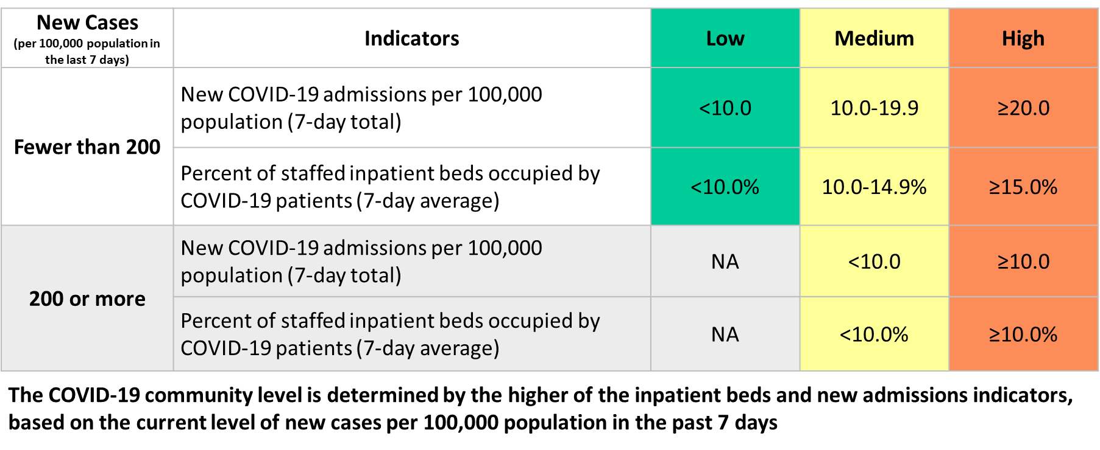
Slide 2: Community transmission levels as defined by CDC guidance
These data are for the 15 counties across Southwestern Ohio, Southeastern Indiana, and Northern Kentucky. The top map illustrates the current level as defined by the CDC. Levels are defined according to the criteria depicted in the table, including measures of new cases per 100,000 people per county in the preceding week, hospital admissions per 100,000 people per hospital service area, and the % of beds occupied by COVID-19 patients in the hospital service area. The table on the right displays, for each regional county, these parameters. A map of new case incidence is displayed in the below, left. The color scheme follows the old CDC thresholds (low, moderate, substantial, and high) with maroon now indicating incidence above the 200 new cases per 100,000 in the preceding 7 days threshold now used to determine community transmission level. The source for these data is the CDC (https://www.cdc.gov/coronavirus/2019-ncov/science/community-levels.html).

Hospital burden

Slide 3: Number of positive COVID-19 patients in Region 6 hospitals
These data are from the Ohio Hospital Association (OHA) resource tracker. The top frame illustrates the total number of COVID-positive patients in hospital beds, measured over time. The height of the orange represents all COVID-19 positive patients in hospitals. The height of the purple represents the subset who are in intensive care units (ICU). The height of the green represents the subset who are on ventilators. There are then 3 panels below. The chart on the left represents the % of all patients who are hospitalized who are positive for COVID-19. The middle chart illustrates the % of COVID-19 patients who are in the ICU. Finally, the chart on the right depicts the % of all COVID-19 positive ICU patients who are on ventilators. These data include all Ohio-based hospitals in Region 6, which includes 8 counties in Southwest Ohio: Hamilton, Butler, Warren, Clermont, Clinton, Brown, Highland, and Adams.

Slide 4: Number of positive COVID-19 patients in Region 6 hospital beds (left) and ICUs (right), Statistical Process Control (SPC) Chart
These charts present the daily number of positive COVID-19 patients in hospital and ICU and hospital beds in Ohio-based hospitals of Region 6, which includes 8 counties in Southwest Ohio: Hamilton, Butler, Warren, Clermont, Clinton, Brown, Highland, and Adams. The source is the OHA resource tracker. The y-axis is the number of patients in beds and the x-axis is time measured in days. The center line in between the points is fit to the direction of the points. The shading represents what would be consider standard, or common variation across the fit line. Given trends, we expect daily values within the shaded line. When a change is signaled, the trend line is recalculated. The dashed center line is reflective of a temporary center line that will change over time. These data are focused on trends over the preceding 30 days.

Slide 5: Percentage of adult beds occupied in the Greater Cincinnati area
This slide illustrates the daily percentage of ICU beds (left) and medical-surgical beds (right) in use across Greater Cincinnati. The source for these data is the SurgeNet system which includes data input by each hospital regionally, inclusive of hospitals within Region 6, and those across state lines. The green-orange-red-black coloration indicates staffing strain. The upper limit reflects current staffing capabilities that may be beyond the region’s normal staffing capacity. This number is subject to change. The coloration depicts the degree of strain. Green indicates ‘Usual operations and staffing.’ Orange indicates ‘Mild to moderate staffing strain; staff
managing higher than usual patient volumes.’ Red indicates ‘Moderate to extreme staffing strain; staff pulled from other areas to manage care outside usual scope. Black indicates ‘Critical operations.’

Context of regional pandemic

Slide 6: Incidence - Weekly SARS-CoV-2 cases measured per 100,000 per week (7-day average per county)
This slide shows this value for each regional county. Data are obtained from the CDC (https://data.cdc.gov/resource/nra9-vzzn.csv). Cuts are defined as low (0-9.99), moderate (10-49.99), substantial (50-99.99), or high (≥100). These align with previous CDC cut-points as in the table to the right. We have added a new ‘maroon’ zone which indicates incidence above 200 new cases per 100,000 people per week to align with the information depicted in slide 2 above. Of note, incidence <10 is suppressed and thus may be blank on the figure.

Slide 7: Age group incidence - Daily positive SARS-CoV-2 cases measured per 100,000 per week (7-day average) – Southwestern Ohio counties (Region 6)
This slide displays the case incidence rate by age group for the 8 counties in Southwest Ohio that compose Region 6. The numerator is the number of cases as identified in the Ohio Department of Health dashboard. The denominator is number of people within each age group within the counties composing Region 6 in Southwest Ohio, as captured in the US Census 2019 population estimates. The rate is normalized by 100,000 individuals. Given lags in the reporting, the last several data points (depicted as dots) are preliminary counts. They should be considered a ‘floor.’

Slide 8: Number of COVID-19 deaths in Southwestern Ohio
This slide shows the daily number of COVID-19 deaths in the 8-county region Southwestern Ohio region. Each lightly shaded bar is the number of deaths reported each day. The line represents a 7-day moving average. These data are tracked by and drawn from Ohio Department of Health (https://coronavirus.ohio.gov/static/dashboards/COVIDDeathData_CountyOfResidence.csv). These data can lag up to 1-2 months. Thus, the dotted line and lightly shaded data points should be considered preliminary.

Testing

Slide 9: Percentage of test results returned positive and number of tests completed for 14-county region
This slide shows the daily number of SARS-CoV-2 (or COVID-19) tests completed by labs from Greater Cincinnati
health systems (bottom), and the percentage of tests that were positive for the virus (top). Each are measured as 7-day moving averages. These data are shared from The Health Collaborative’s health information exchange. The most recent 3 days are subject to change.

Slides 10-11: Percentage of test results returned positive and number of tests completed by age of patient
These slides are set up exactly like slide 9 just now split by age group. They show the percentage of daily SARS-CoV-2 (or COVID-19) tests from Region 6 that were positive for SARS-CoV-2 for different age groups as 7-day moving averages. The bottom panels illustrate the average daily testing number by age of patient. These data are shared from The Health Collaborative’s health information exchange. The most recent 3 days are subject to change.

Vaccination

Slide 12: Percentage of the population who has completed their vaccine series by regional county
These data are for 15 counties across Southwestern Ohio, Southeastern Indiana, and Northern Kentucky. The population-weighted average for the entire region is also provided. The numerator is the number of people who have received at least their 2nd dose of the Pfizer or Moderna vaccine or the single dose of the Johnson & Johnson vaccine. The denominator is all individuals within the geography in question. For information on how to get vaccinated, please go to http://testandprotectcincy.com. The source for these data is the CDC, available at: https://covid.cdc.gov/covid-data-tracker/#county-view. Denominators are obtained from the US Census

Slide 13: Cumulative vaccination by county
Here, we look at the cumulative % of each regional county that has started (blue), completed (orange), and boosted (purple) their vaccination series. Starting the series means having received the 1st dose of the Pfizer or Moderna vaccine). Completing the series means having received the 2nd dose of the Pfizer or Moderna vaccine or the single dose of the Johnson & Johnson vaccine. Boosted means having a 3rd dose of the Pfizer or Moderna vaccine, a second dose of the Johnson & Johnson vaccine, or a 1st dose of the Pfizer or Moderna vaccine after an initial Johnson & Johnson dose. The source for these data is the CDC, available at: https://covid.cdc.gov/covid-data-tracker/#county-view. Denominators are obtained for the US Census.

Slide 14: Cumulative vaccination by region
Slide 14 is a companion to slide 13, set up much the same way. The top left depicts vaccination started, completed, and boosted for the 4 Northern Kentucky counties (Boone, Campbell, Grant, Kenton). The top right is for the 3 Southeastern Indiana counties (Franklin, Dearborn, Ripley). The bottom left is for the 8 Southwestern Ohio counties (Adams, Brown, Butler, Clermont, Clinton, Hamilton, Highland, Warren). Finally, the bottom right depicts the region as a whole. Again, the source for these data is the CDC, available at: https://covid.cdc.gov/covid-data-tracker/#county-view. Denominators are obtained for the US Census.

Slide 15: Vaccination and Cases
This slide includes two panels. The panel on the left is a zip code map of Hamilton County, Ohio. Zip codes are colored according to the % of the population that has at least started their vaccine series. A histogram illustrative of the distribution is depicted below the map. The panel on the right is also a zip code map of Hamilton County, Ohio, this time depicting incidence of new cases per 100,000 individuals in the preceding 14 days. The histogram illustrating the distribution of incidence across county zip codes is depicted below. The source of these data is the Ohio Department of Health.

Slide 16: Racial inequities in COVID-19 cases, hospitalizations, and deaths
These data emerge from the Ohio Department of Health dashboard. Specifically, we depict differences in COVID-19 cases, hospitalizations, and deaths by race. We are only able to look at those who identify as Black and those who identify as white given limitations/missingness of data for other races. The chart on the left depicts cases. The orange line is the case rate per 100,000 people for those who identify as Black; the blue line is for those who identify as white. The green bar depicts the ratio of Black:white cases since July 2021. The middle chart is set up much the same way except depicts hospitalizations. The chart on the far right depicts deaths. The gray shading on the right side of each chart reflects points that should be considered preliminary. Please not that the y-axis differs for each included chart.

*Note: we no longer display effective reproductive numbers (R). We made the decision to remove these from the deck given that now Ohio Department of Health, like many state agencies across the U.S., has moved to just weekly reporting frequency. Without the daily cadence of data, R becomes a less useful metric. Should conditions warrant a return to more frequent reporting, we will consider re-establishing R as a measure to share.

